Project Report

"Website Based Assignment"

Submitted to

Rahul Rajput Singh

LOVELY PROFESSIONAL UNIVERSITY

PHAGWARA, PUNJAB



SUBMITTED BY

Name of Student: K. Varun Sai Nadh

Registration Number: 12206253

“School of Computer Science and Engineering”

Abstract
This project report details the development of an interactive N Queen Problem Visualizer implemented in Java using Swing. The primary goal was to create a tool that not only solves the N Queen problem but also provides a graphical representation of the solving process. This project aims to enhance understanding of backtracking algorithms through real-time visualization.

Introduction
The N Queen problem is a classic combinatorial problem where N queens must be placed on an N×N chessboard such that no two queens threaten each other. This project focuses on developing a graphical interface using Java Swing to illustrate the placement and backtracking of queens as they are recursively placed and removed to find a valid solution.

Objectives
- Algorithm Implementation: Implement the backtracking algorithm to solve the N Queen problem efficiently.
- Graphical User Interface: Develop a Java Swing application to visualize the chessboard and dynamically display queen placements and backtracking steps.
- Educational Tool: Provide a tool that aids in understanding the mechanics of the backtracking algorithm through visual representation.

Methodology
- Algorithm Selection: The backtracking algorithm was chosen for its ability to systematically explore potential solutions while efficiently backtracking when conflicts arise. It recursively attempts to place queens on the board, checking each placement's validity against established constraints.
- Graphical User Interface Design: Java Swing was utilized to create a 4×4 grid representing the chessboard. Each cell on the grid was represented by a JLabel, allowing for easy customization of visual properties such as color to denote queen placements and backtracking steps.
- Visualization Approach: Queens' placements and backtracking steps were visually represented using colour changes on the JLabels. This approach provided a clear and intuitive representation of the solving process, with each step animated to aid comprehension.

Implementation Code :-
Here's the Java code for the N Queen Problem Visualizer, explained step by step:

import javax.swing.*;
import java.awt.*;
import java.util.ArrayList;
import java.util.List;
import java.util.concurrent.Semaphore;

public class NQueensSolverVisualizer extends JPanel {
private int[] queens;
private int n;
private static final int CELL_SIZE = 50;
private static final int DELAY = 390;
private List<int[]> solutions = new ArrayList<>();
private int currentSolutionIndex = 0;
private final Semaphore semaphore = new Semaphore(0);

public NQueensSolverVisualizer(int n) {
this.n = n;
queens = new int[n];
for (int i = 0; i < n; i++) {
queens[i] = -1;
}
setPreferredSize(new Dimension(n * CELL_SIZE, n * CELL_SIZE));
}

public void findAllSolutions() {
solve(0);
showAllSolutionsFoundDialog();
displayNextSolution();
}

private boolean solve(int row) {
if (row == n) {
int[] solution = queens.clone();
solutions.add(solution);
showSolutionFoundDialog();
waitForUser();
return true;
}
boolean found = false;
for (int col = 0; col < n; col++) {
if (isSafe(row, col)) {
queens[row] = col;
repaintAndSleep();
if (solve(row + 1)) {
found = true;
}
queens[row] = -1;
repaintAndSleep();
}
}
return found;
}

private boolean isSafe(int row, int col) {
for (int i = 0; i < row; i++) {
if (queens[i] == col || Math.abs(queens[i] - col) == Math.abs(i - row)) {
return false;
}
}
return true;
}

private void repaintAndSleep() {
repaint();
try {
Thread.sleep(DELAY);
} catch (InterruptedException e) {
Thread.currentThread().interrupt();
e.printStackTrace();
}
}

private void showSolutionFoundDialog() {
SwingUtilities.invokeLater(() -> {
JOptionPane.showMessageDialog(this, "SOLUTION FOUND. COUNT= " + solutions.size());
semaphore.release();
});
}

private void showAllSolutionsFoundDialog() {
SwingUtilities.invokeLater(() -> JOptionPane.showMessageDialog(this, "ALL SOLUTIONS FOUND. Count = " + solutions.size()));
}

private void waitForUser() {
try {
semaphore.acquire();
} catch (InterruptedException e) {
Thread.currentThread().interrupt();
}
}

private void displayNextSolution() {
if (!solutions.isEmpty()) {
currentSolutionIndex = (currentSolutionIndex + 1) % solutions.size();
queens = solutions.get(currentSolutionIndex).clone();
repaintAndSleep();
}
}

private void printAllSolutions() {
for (int[] solution : solutions) {
for (int i = 0; i < n; i++) {
for (int j = 0; j < n; j++) {
if (solution[i] == j) {
System.out.print("Q ");
} else {
System.out.print(". ");
}
}
System.out.println();
}
System.out.println();
}
System.out.println("Total solutions: " + solutions.size());
}

@Override
protected void paintComponent(Graphics g) {
super.paintComponent(g);
for (int row = 0; row < n; row++) {
for (int col = 0; col < n; col++) {
if ((row + col) % 2 == 0) {
g.setColor(Color.WHITE);
} else {
g.setColor(Color.GRAY);
}
g.fillRect(col * CELL_SIZE, row * CELL_SIZE, CELL_SIZE, CELL_SIZE);
if (queens[row] == col) {
g.setColor(Color.GREEN);
g.fillOval(col * CELL_SIZE + 10, row * CELL_SIZE + 10, CELL_SIZE - 20, CELL_SIZE - 20);
}
}
}
}

public static void main(String[] args) {
SwingUtilities.invokeLater(() -> {
String input = JOptionPane.showInputDialog("Enter the size of the board (n):");
int n;
try {
n = Integer.parseInt(input);
if (n <= 0) throw new NumberFormatException();
} catch (NumberFormatException e) {
JOptionPane.showMessageDialog(null, "Invalid input. Please enter a positive integer.");
return;
}

NQueensSolverVisualizer solverVisualizer = new NQueensSolverVisualizer(n);
JFrame frame = new JFrame("N-Queens Solver");
frame.add(solverVisualizer);
frame.pack();
frame.setDefaultCloseOperation(JFrame.EXIT_ON_CLOSE);
frame.setLocationRelativeTo(null);
frame.setVisible(true);

new Thread(() -> {
solverVisualizer.findAllSolutions();
solverVisualizer.printAllSolutions();
}).start();

JButton nextButton = new JButton("Next Solution");
nextButton.addActionListener(e -> {
solverVisualizer.displayNextSolution();
});
frame.add(nextButton, BorderLayout.SOUTH);
});
}
}

Explanation
- Imports and Class Definition:
  - javax.swing.* and java.awt.* for GUI components.
  - java.util.ArrayList, java.util.List, and java.util.concurrent.Semaphore for data storage and concurrency.
- Class Variables:
  - queens array to store the position of queens.
  - n for board size.
  - CELL_SIZE and DELAY for visual appearance and delay.
  - solutions list to store all found solutions.
  - currentSolutionIndex to track the current solution being displayed.
  - semaphore to control the flow of execution, pausing the solver when a solution is found.
- Constructor:
  - Initializes the board size n.
  - Initializes the queens array to -1.
  - Sets the preferred size of the JPanel.
- Finding All Solutions:
  - findAllSolutions method starts the recursive solving process, shows a dialog when all solutions are found, and displays the first solution.
- Solving the N-Queens Problem:
  - solve(int row) is a recursive method that tries to place queens row by row.
  - If a solution is found (row == n), it clones the queens array and adds it to the solutions list, then shows a dialog and waits for user input.
  - For each column in the current row, it checks if placing a queen is safe, places the queen, and proceeds to the next row.
  - If no column is safe, it backtracks by resetting the position of the queen in the current row.
- Checking Safety:
  - isSafe(int row, int col) method checks if placing a queen at (row, col) is safe by ensuring no queens threaten each other.
- Repainting and Sleeping:
  - repaintAndSleep method repaints the board and pauses for a short delay to visualize the solving process.
- Showing Dialogs and Waiting:
  - showSolutionFoundDialog shows a dialog when a solution is found and releases the semaphore.
  - showAllSolutionsFoundDialog shows a dialog when all solutions are found.
  - waitForUser method waits for the semaphore to be released, effectively pausing the solver until the user clicks "OK".
- Displaying Next Solution:
  - displayNextSolution method displays the next solution in the list.
- Printing All Solutions:
- printAllSolutions method prints all found solutions to the console.
- Painting the Board:
- paintComponent(Graphics g) method draws the chessboard and queens on the panel.
- Main Method:
- Sets up the GUI, prompts the user for board size, and starts the solving process in a new thread.
- Adds a "Next Solution" button to cycle through the solutions.

Results
Upon executing the program, a JFrame titled "N Queen Problem Visualizer" will open, displaying a 4x4 grid representing the chessboard. Queens' placements and backtracking steps will be visualized using color changes on the JLabels within the grid. Green color indicates queen placement, and red color indicates backtracking.
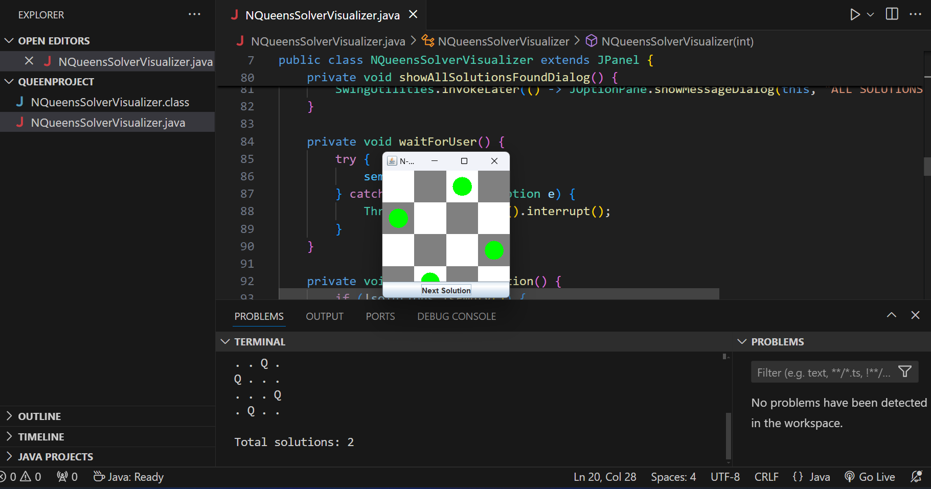

Conclusion
The N Queen Problem Visualizer using Java Swing provides an interactive and educational tool for exploring the backtracking algorithm in combinatorial problem-solving. By combining algorithmic complexity with graphical representation, this project provides a valuable resource for learning and understanding the mechanics of solving the N Queen problem.

Future Work
- Expand Board Size: Extend the program to handle larger chessboards (e.g., 8 Queen problem) to demonstrate scalability and performance considerations.
- Enhance User Interaction: Implement features for user input, such as allowing customization of board size and dynamically loading different N Queen configurations.
- Optimize Visualization: Improve graphical representation for smoother animation and enhanced user experience, potentially adding features like step-by-step controls and visual statistics.

Références
- Java Swing Documentation: Oracle Java Swing Tutorial
- Backtracking Algorithm: GeeksforGeeks - N Queen Problem

Appendix
- Code Repository: https://github.com/Surajgupta63

THANK YOU🙂

